SMAP 3
Software Architecture Document

Version 1.0

Revision History
Date | Version | Description | Author
24/Apr/2009 | 0.9 DRAFT | Initial document | Rakkitha Ilukpitiya
29/Apr/2009 | 1.0 DRAFT | DM edit | David McCreary
11/May/2009 | 1.0 DRAFT | Updated logical view section |  | Rakkitha Ilukpitiya
25/June/2009 | 1.0 Final | Final |  | Rakkitha Ilukpitiya, David McCreary

Table of Contents
1. Introduction to sMAP 4
1.1 Purpose 4
1.2 Scope 4
1.3 Definitions, Acronyms, and Abbreviations 5
1.4 Related Documents 5
1.5 Overview 5
2. Architectural Representation 6
3. Architectural Decisions 8
4. Use-Case View 11
4.1 Use-Case Realizations 13
5. Implementation View 15
5.1 Overview 15
5.2 Layers 16
6. Logical View 18
6.1 Overview 18
6.2 Architecturally Significant Design Packages 18
7. Data View 19
8. Size and Performance 20
9. Quality 20
9.1 Extensibility 21
9.2 Reliability 21
9.3 Portability 21
9.4 Adaptibility 21
9.5 Sustainability 21

Software Architecture Document

Introduction to sMAP

Purpose

This document provides a comprehensive architectural overview of the system, using a number of different architectural views to depict different aspects of the system. It is intended to capture and convey the significant architectural decisions which have been made on the system.
The development team can use this document to review the architecture of the system. The Architecture document will be also useful for future development teams.

Scope

The project will aim to develop a system for electronically collecting data tagged with location. The initial customer will be World Vision who will use the system in developing countries. World Vision will provide requirements and data to test the resultant system and an IBM employee will provide technical guidance to the project team.

The technical environment will consists of Java application servers, web services and mobile phones equipped with a GPS and running Java. The server application will be deployed into a hosted environment (cloud computing). The project will suit a team of 4 developers and will be technically demanding requiring software development for a mobile device and an application server as well as providing application support to the customer. Web Services integration will be a key part of the solution.

World Vision are planning a pilot to evaluate the benefits of this technology which are expected to include faster, higher quality base-lining and monitoring of World Vision development projects.

This project will continue the trend within the program from exploratory R&D work to producing commercial strength software. For this reason the scope of the project will be more targeted than the previous projects to allow the team to focus on producing a component that can be used directly by the client. The key work required is:

- Enhance the mobile phone application developed by SMAP2. This application should work well for the survey intended for Cambodia in May. However other surveys that World Vision are planning could not be supported. Some of the changes required will be:

  - Enable the mobile phone application to execute any of the surveys created by component 1 above.
  - Localization through adding support for Unicode fonts
  - Improving device flexibility by adding support for NMEA / external Bluetooth GPS

- Create a new survey management component that can be used by customer staff to create a survey. This should be flexible enough to create any survey that is capable of being stored in the survey database and processed by the Mobile Phone application.
- Create a new data extract application that will retrieve the results of a survey from the database and make it available in a format suitable for loading into an analysis application (This analysis application will probably be a spreadsheet)

- Recommend and install a map navigation application on the mobile phone to assist the surveyor in finding the survey point.

Definitions, Acronyms, and Abbreviations

For a detailed listing of all definitions, acronyms, and abbreviations used in the project, please see Project Definition, Section 11

Related Documents

Name | Author | Description
Project Schedule | David McCreary | Detailed Work Breakdown Schedule – MS Project
Project Charter | Dev. Team | Comprehensive overview of project
Project Proposal | Neil Penman - IBM | High level overview of project
Project Definition | Dev. Team | Detailed Project Plan

Overview

The rest of the document will elaborate on the system from an architectural point of view. It will contain diagrams showing the showing the Architecture overview, deployment view, process view, use case view, logical view, deployment view, implementation view and data view.
It will also describe the significant architectural definitions that were done during the architecture design phase. Furthermore the document will also contain use case realizations with scenarios

Architectural Representation

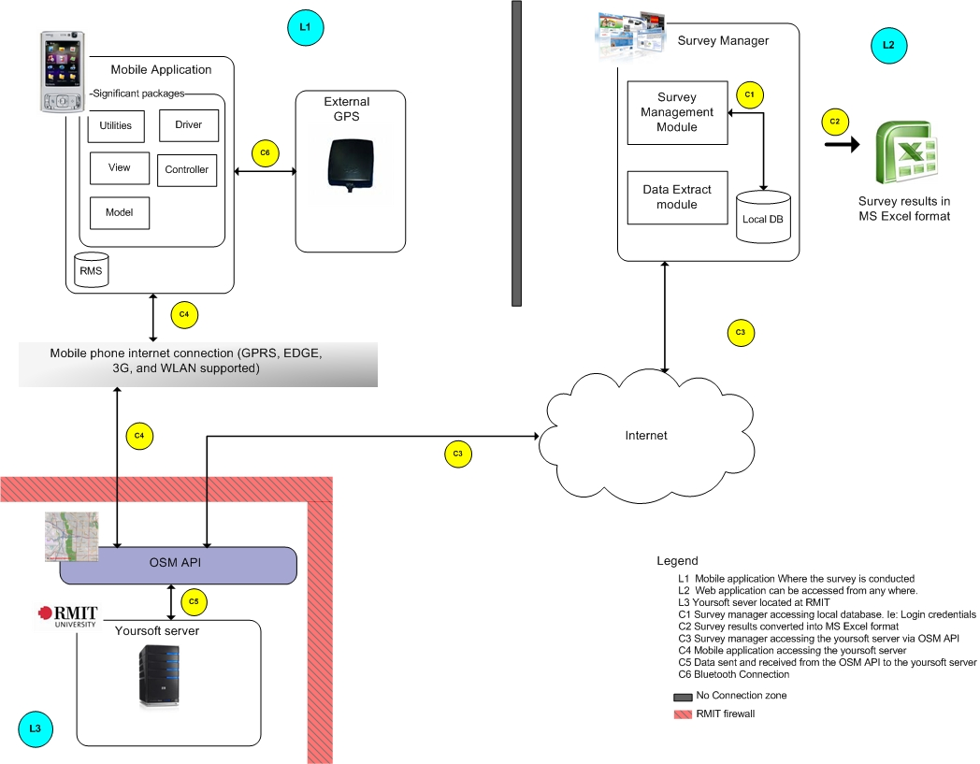

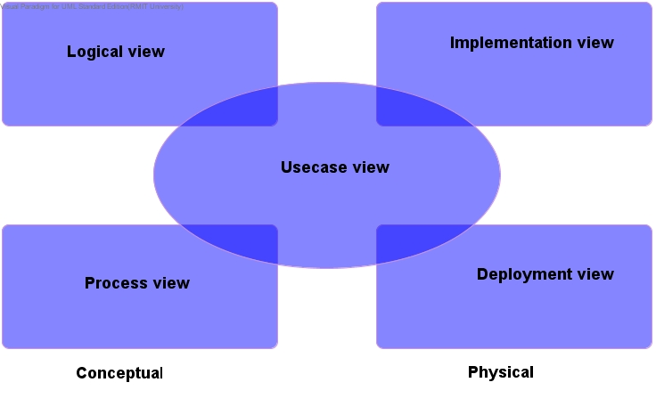
The above diagram represents the overall diagram of the proposed system. Furthermore the architecture for the proposed system will be broken down using the 4 + 1 Architectural Model.

- Logical view: The logical view is concerned with the functionality that the system provides to end-users. UML Diagrams to represent logical view include Class Diagram, Communication diagram, Sequence diagram

- Development view: The development view illustrates a system from a programmer’s perspective and is concerned with software management. This view is also known as the implementation view. It uses the UML component diagram to describe system components. UML Diagrams to represent development view include the Package diagram

- Process view: The process model deals with the dynamic aspect of the system, explains the system processes and how they communicate, and focuses on the runtime behaviour of the system. The process view addresses concurrency, distribution, integrators, performance, and scalability, etc. UML Diagrams to represent process view include the Activity diagram

- Physical view: The physical view depicts the system from a system engineer's point-of-view. It is concerned with the topology of software components on the physical layer, as well as communication between these components. This view is also known as the deployment view. UML Diagrams to represent physical view include the Deployment diagram

- Scenarios: The description of architecture is illustrated using a small set of use cases, or scenarios which become a fifth view. The scenarios describe sequences of interactions between objects, and between processes. They are used to identify architectural elements and to illustrate and validate the architecture design. They also serve as a starting point for tests of an architecture prototype. UML Diagram(s) used to represent scenario view include the Use case diagram

Architectural Decisions

Subject Area | Web development and run time environment
Architectural Decision | Use of Apache Tomcat as Survey Manager Platform | ID | AD001
Issue or Problem Statement | A web server will be used as a framework for the web based application. A variety of alternatives were chosen for the project.
Assumptions | A server computer exists with Fedora operating system version 9 installed.
Motivation | The project needed a web server to interface with the user during survey creation and interact with the OSM api
Alternatives | Apache Geronimo, Websphere sMASH
Justification | Apache Tomcat was chosen because it is open source and has been used previously by development team members. Open Source was necessary to continue with the spirit of the project. Websphere sMASH was considered by its license was deemed too restrictive to the openness of the project. Apache Geronimo was another option, but lacks the ease of use and simplicity of Apache Tomcat.

Subject Area | Security
Architectural Decision | Use of Apache Tomcat as SSL relay to project server | ID | AD002
Issue or Problem Statement | The OSM API and database are designed for open collaboration. Thus, no methods are in place for secure connection to the database, which the client deemed necessary for their project.
Assumptions | Apache Tomcat is used as the project web server
Motivation | The client desired a way to secure usernames and passwords from client to server. OSM supports basic authentication, which was deemed not secure enough.
Alternatives | Creating separate proxy relay from scratch, modifying OSM API to allow HTTP digest authentication
Justification | Using Apache Tomcat as an SSL relay was chosen because it gives excellent security while still maintaining the closest interoperability with the existing OSM standard. The client application will be designed to support both secure and unsecure communication, with the choice available in the configuration menu. SSL was also chosen over HTTP digest over its superior encryption standards.

Subject Area | Khmer Input
Architectural Decision | Use of FontRouter and a custom font to represent Khmer input and display | ID | AD003
Issue or Problem Statement | The Nokia N95 in factory condition does not have Khmer input our display capability.
Assumptions | Nokia N95 used as survey device
Motivation | The client deemed it necessary to display surveys in the Khmer language to enable proper data collection by native Cambodian staff.
Alternatives | Java library that changes True Type fonts to vector graphics, FontRouter with standard Khmer font
Justification | Using FontRouter and a custom font was necessary to achieve the client’s request for Khmer input and display. The Java library (TTF to vector graphics) was only able to be displayed on a Canvas screen, while TextInput was necessary for project use. FontRouter using a standard Khmer font did not work due to the phones limited support for the Unicode standard. All input to/from the server will be in standard Unicode, however.

Use-Case View
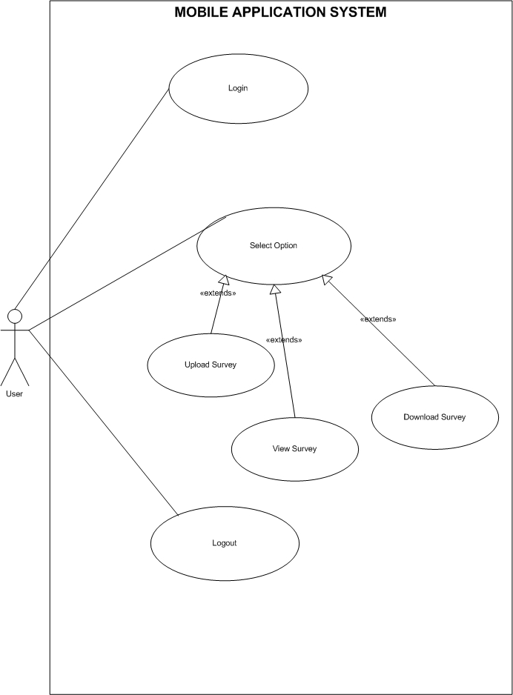

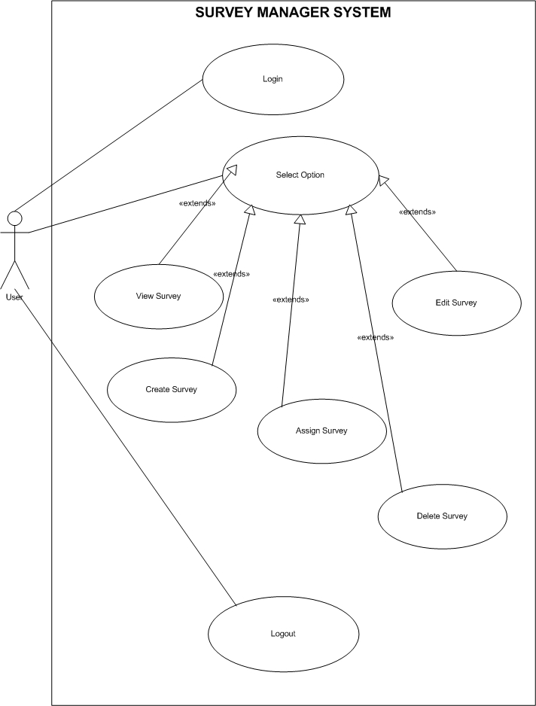

Use-Case Realizations

NAME | Login
DESCRIPTION | This use case will be used to check the correctness of a given user name and password. The user name and password are already stored in the server.
ACTORS | Mobile application user (Field Officer).
PRECONDTIONS | The user must have a valid user name and password.
BASIC FLOW OF EVENTS | User fill in the user name and password, the information is sent to the server for validation.
ALTERNATIVE EVENT | NA
KEY SCENARIOS | - User provides the username and password.  - The account information is sent to the server for validation.  - Based on the provided information the server response with either true or false.
POST CONDITIONS | Successful login.
SPECIAL REQUIREMENTS | NA
ADDITIONAL REQUIREMENTS | NA

NAME | Upload survey
DESCRIPTION | Initiates a function to upload any survey which has been specified by the user.
ACTORS | Mobile application user (Field Officer).
PRECONDTIONS | - The user must fill at least one survey.  - The survey has to be already stored in the mobile local storage.
BASIC FLOW OF EVENTS | User select the survey, then click the on the upload button.
ALTERNATIVE EVENT | NA
KEY SCENARIOS | - The wanted survey is selected.  - Issue an upload command which will connect to the server and sending the survey.  - After uploading the survey is deleted.
POST CONDITIONS | The uploaded survey is uploaded and deleted from the local storage.
SPECIAL REQUIREMENTS | NA
ADDITIONAL REQUIREMENTS | NA

NAME | View survey
DESCRIPTION | Views the chosen survey on the client side (mobile phone).
ACTORS | Mobile application user (Field Officer).
PRECONDTIONS | At least one survey is stored on the mobile phone.
BASIC FLOW OF EVENTS | User chose the survey, the click to view.
ALTERNATIVE EVENT | NA
KEY SCENARIOS | - User selects a survey to view.  - Click a button to view.  - The mobile application restores the survey file(s) and then views it on the screen.
POST CONDITIONS | Successfully viewed the survey.
SPECIAL REQUIREMENTS | NA
ADDITIONAL REQUIREMENTS | NA

NAME | Download survey
DESCRIPTION | Downloads survey files from the server.
ACTORS | Mobile application user (Field Officer).
PRECONDTIONS | At least one survey exists on the server.
BASIC FLOW OF EVENTS | User chose to download a survey from the server, the mobile application then views it on the screen.
ALTERNATIVE EVENT | NA
KEY SCENARIOS | - User selects to download a survey from the server.  - The server response with the requested file.  - Mobile application then acts and views the downloaded survey on the screen.
POST CONDITIONS | Successfully download the survey.
SPECIAL REQUIREMENTS | NA
ADDITIONAL REQUIREMENTS | NA

Implementation View

Overview

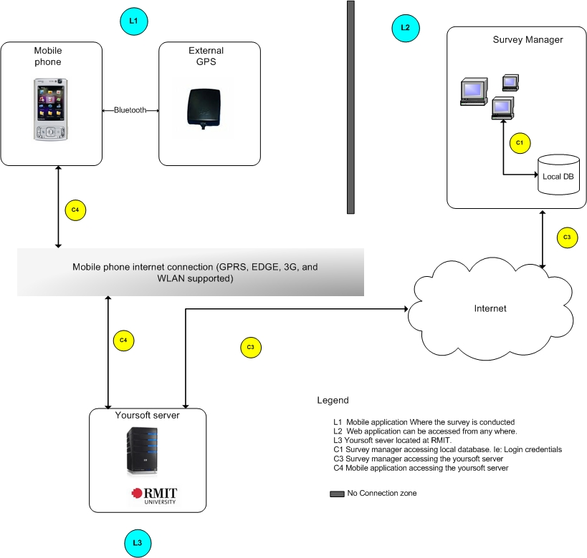

Layers

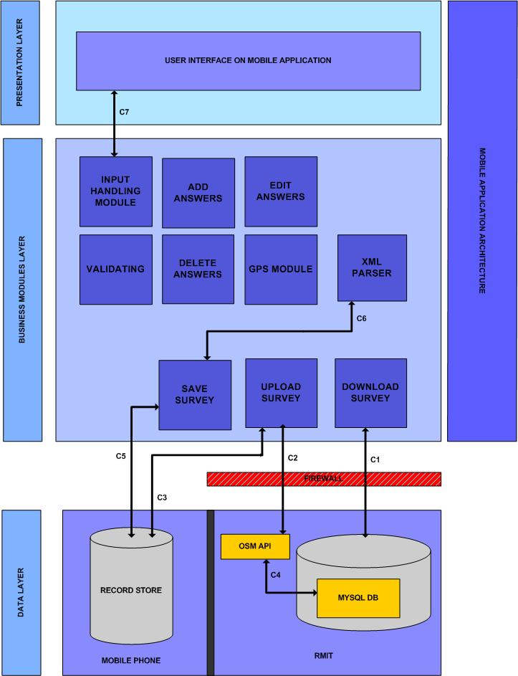
Mobile Application
VIEW
CONTROLLER
MODEL
UTILITIES
RMS
YOURSOFT SERVER
Java Virtual Machine
Phone OS
Phone Hardware
MOBILE APPLICATION ARCHITECTURE
OSM API

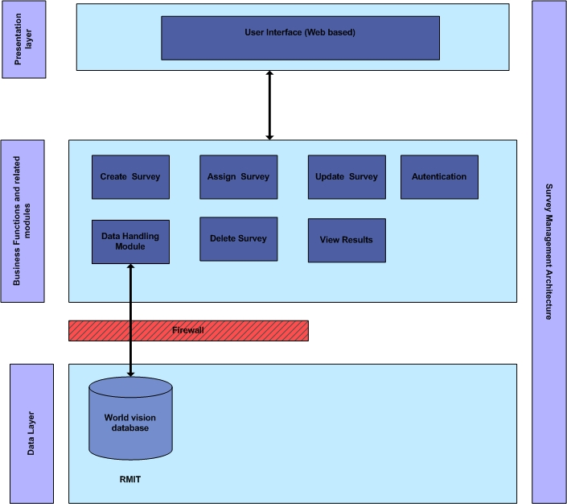

Survey Manager

WEB INTERFACE (HTML)
Admin
Database
Servlets
JSP
OSM API
OSM
J2SE
Apache Tomcat

Logical View

Overview

Mobile application
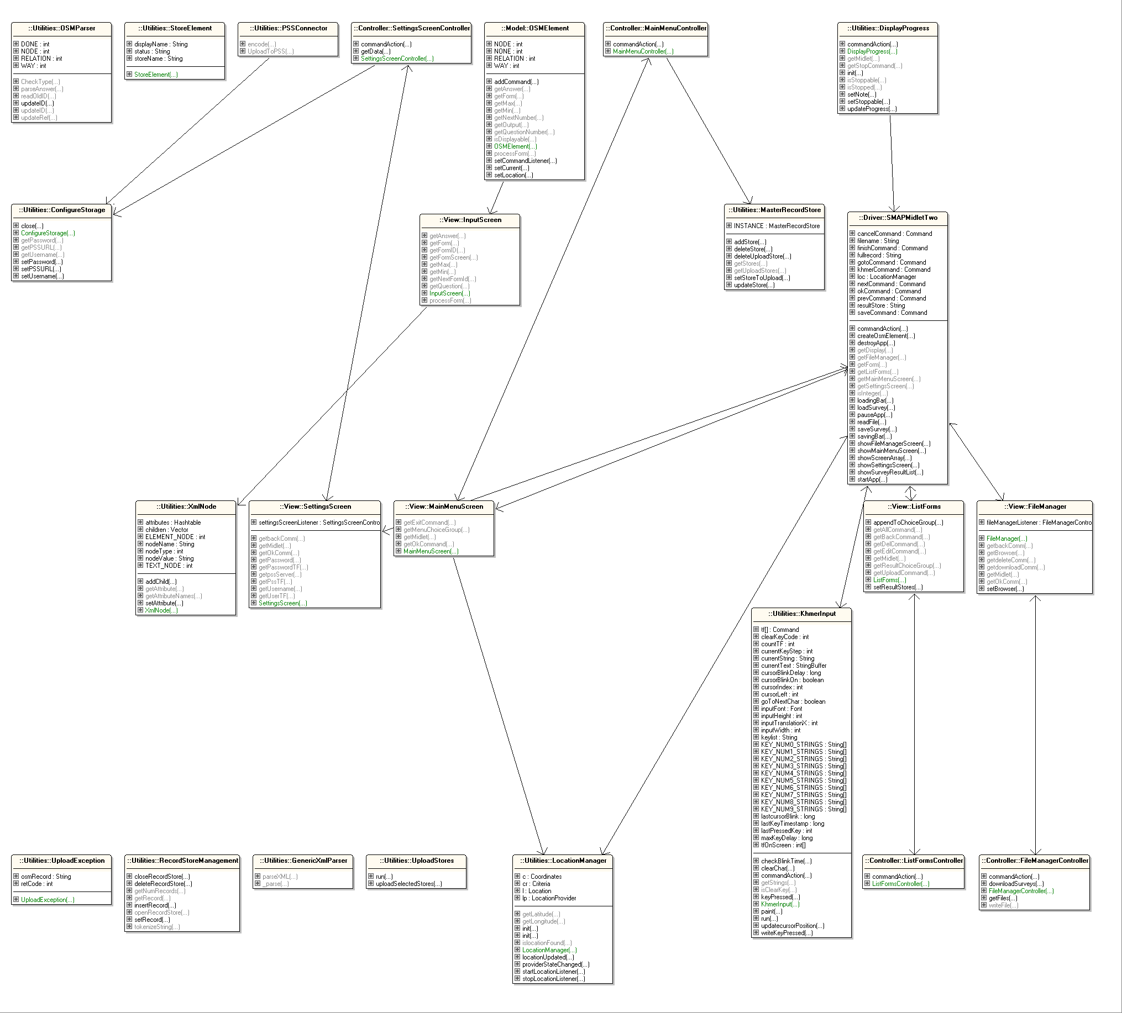

The flowing class diagram shows part of the survey manager

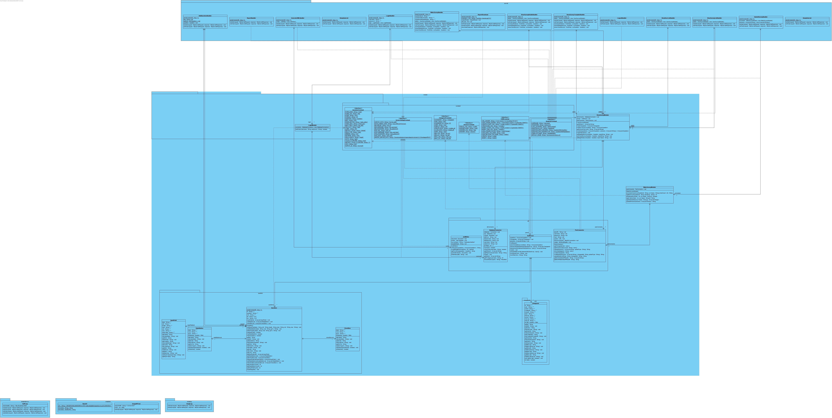

The following sequence diagram depicts the most important section of the mobile application uploading the survey

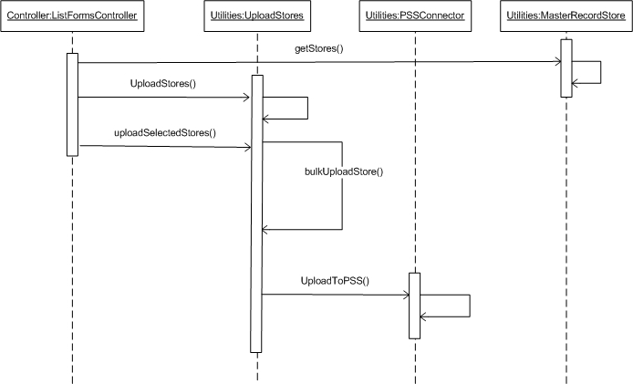

Architecturally Significant Design Packages

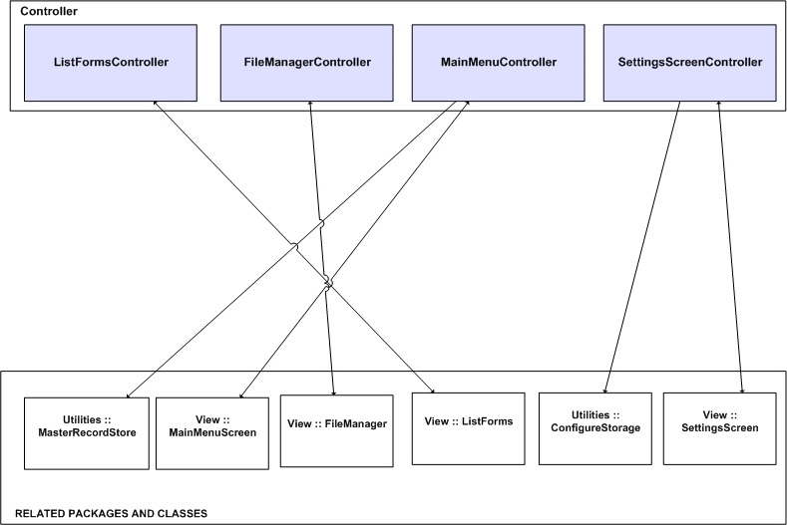

Class | Description
ListFormsController | Enables users to edit/upload/delete survey results.
FileManagerController | Enables users to download/delete survey templates.
MainMenuController | Enables users to select menu items
SettingsScreenController | Enables users to change application settings

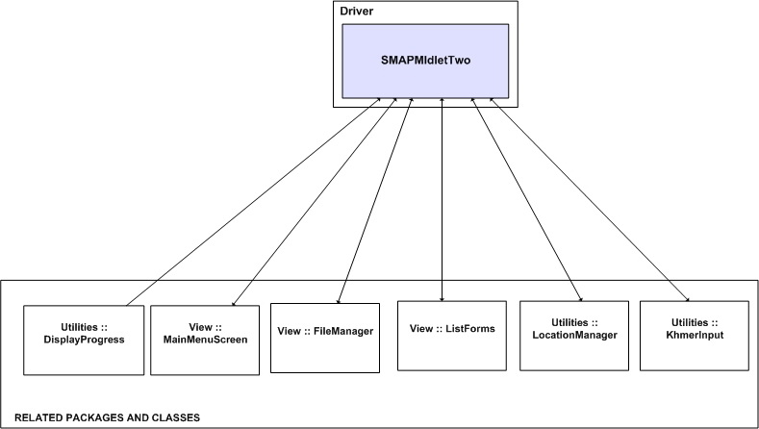

Class | Description
SMAPMidlet | Main midlet

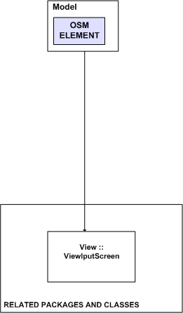

Class | Description
OSMElement | Converts xml to osm data style.

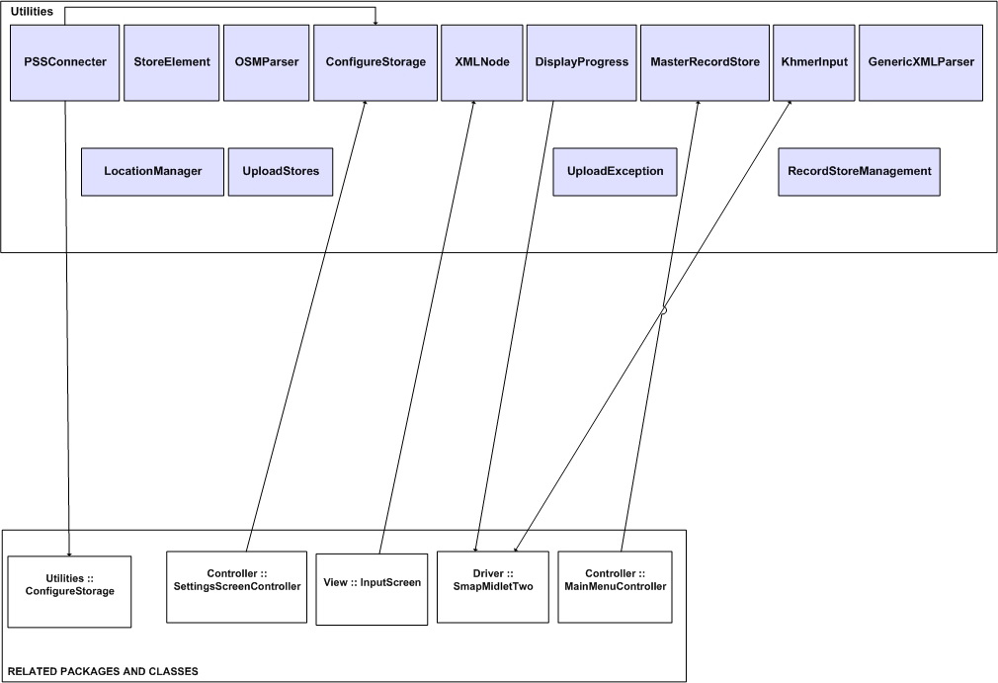

Class | Description
PSSConnector | Uploads survey results to the osm database
StoreElement
OSMParser | Parses the osm data
ConfigureStorage | Stores the application settings data.
XMLNode | Gets/sets attributes and child nodes.
DisplayProgress | Please remove this class Rakkitha
MasterRecordStore | Manages the RMS
KhmerInput | Canvas where users can type Khmer characters on screen.
GenericXMLParser | Parses arbitrary XML input
LocationManager | Gets the current location.
UploadStores | Passes osm data to PSSConnector, handles errors during upload process.
UploadException | Any exceptions occurred during the upload process.
RecordStoreManagement | Creates/closes record stores, inserts/deletes data from record stores.

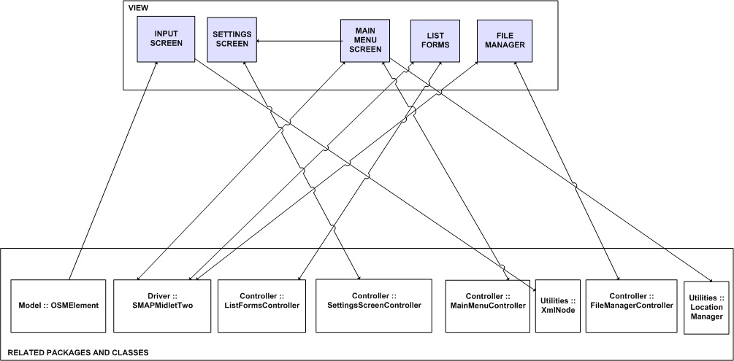

Class | Description
InputScreen | Displays survey questions on the screen.
FileManager | Displays stored survey templates on the screen.
ListForms | Displays the filled survey results on the screen.
MainMenuScreen | Displays the main menu list on the screen.
SettingsScreen | Displays the settings screen.

Data View
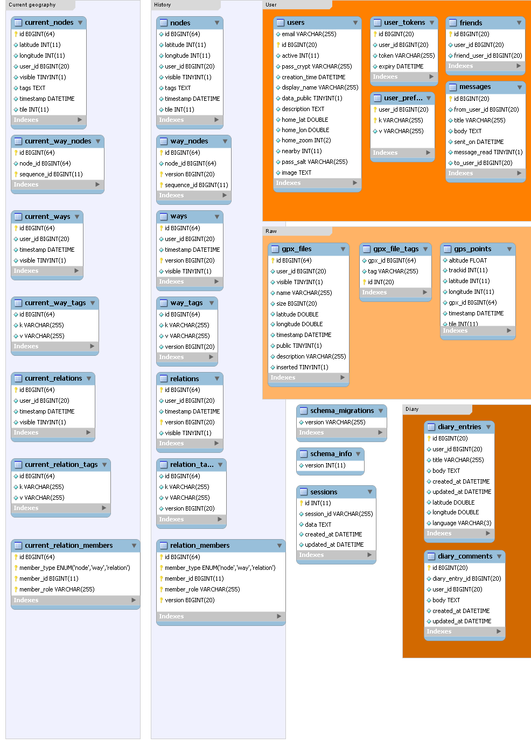
The following data view is inherited from the Open Street Map project:

Source: http://wiki.openstreetmap.org/wiki/Database/Model

Size and Performance

Volumetric
# | Category | Requirement | Value | Comments
1 | Device | Number of forms while offline. | 50 forms | Each device must be capable of doing 50 questionnaires offline before being synchronized.  Plenty of assumptions required here.
2 | PSS App Server – number of devices | Each app server must support a community of up to 1,000 data collection devices | 1,000 devices | Most of these would be offline at any one time
3 | PSS App server – number of back end users | Each app server must support up to 10 concurrent users extracting data for reports | 10 users
4 | Database – years of data storage | The database must be able to store 5 years of data collection from 1,000 devices while maintaining the target performance | 5
5 | SMS App Server | Each SMS app server may have up to 10 concurrent users creating forms.

Performance

# | Category | Requirement | Value | Comments
1 | Uploads | Uploading the results of 10 forms (1 days work) should require no more than 10 minutes of connectivity to the server. | 10 minutes
2 | Downloads | Downloading a form should take no more than 2 minutes. | 2 minutes

Quality

Extensibility

Since this project uses an open and free standard, OpenStreetMap API v 0.6, any program that interfaces with this API in a similar fashion could theoretically be used with the project as well. This gives the project maximum options for extensibility in the future.

Reliability

This OSM database structure has been proven to work on much larger projects than contained in the scope of this project. The mobile application will deal with common connection issues regarding GPRS connections which may include limited signal availability in rural areas.

Portability

The main language used for development will be Java, which will allow the software to be ported easily to numerous other devices. The client application itself is designed with mobile devices in mind, thus taking advantage of the portable characteristics of these devices.

Adaptibility

Since the project is open source, any organization will be able to adapt the program to suit their specific needs. The system is developed using the Java programming language, ensuring adaptation to an organization’s needs can be done by any capable Java programmer.

Sustainability

The deployment of the project shall be well documented in an accompanying deployment document that will describe the installation and configuration of a complete system. Any organization wishing to use the system will be able to follow the deployment guidelines to create a system for their own use.
To ensure long-term viability of the system, the system is developed using popular open-source projects, namely OpenStreetMap, Apache Tomcat, and accepted standards for mobile application development, J2ME.

